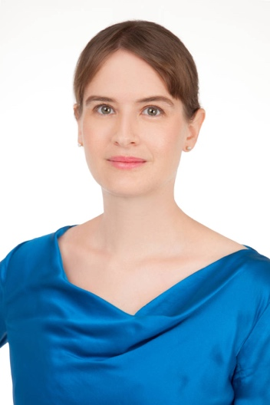
Caroline THOMAS FCIArb

MA Economics and History (Trinity College Dublin)
Diplôme du Programme International (Sciences Po Paris)
LL.M (Columbia University) with focus on arbitration
Fellow of the Chartered Institute of Arbitrators (FCIArb)
Solicitor (Hong Kong and England & Wales, admitted New York)

Contact Details

Director, Arbitratio & Concilium Limited
(Since 2024, additionally Partner with Hauzen LLP - in association with Anjie Broad Law Firm LLP and in affiliation with DWF LLP)
cct2146@columbia.edu; +852 6112 8516

Experience
- Teaching Maritime Arbitration LLAW6328 & JDOC6328 at the University of Hong Kong (fall semester 2025).
- Committee member of Ciarb East Asia Branch since 2023.
- Senior Manager at the Insurance Authority of Hong Kong (2018-20).
- Formerly partner at international insurance, shipping and trade firm in HK (2016-18).
- Previously at two further leading international insurance, shipping, trade law firms.
- Director of Hong Kong Insurance Law Association Limited (HILA) since 2012, responsible for events (e.g. seminars, lectures, conferences).
- Presidential Council member of AIDA Association Internationale de Droit des Assurances and co-head of its Dispute Resolution Working group since 2025.
- Director of ARIAS Asia (and arbitration panel member) since 2023.
- Chartered Insurance Institute (CII) Diploma in Insurance (awarded in 2020).

Some Academic Publications
- Arbitration law in 2024: a review, Lloyd’s List Intelligence, https://static.i-law.com/ilaw/SFE/pdf/2024_LLI_Arbitration_Law_Review.pdf
- Arbitration law in 2023: a review of developments in case law, Lloyd’s List Intelligence, https://static.i-law.com/ilaw/SFE/pdf/2023_LLI_Arbitration_Law_Review.pdf
- Forthcoming, introduction to ISDS Nutshell, edited Professors Bermann and Duggal
- Chapter on transport in book on HK Competition Ordinance (2016), with A. Woolich
- HK chapter in HFW’s Shipping Law Review (2014 & updates in 2015 and 2016), with K. MacNamara, T. Morgan and G. Martin
- HK chapter on Marine Cargo Insurance in HK, Informa (2012), with S. Baker
- HK chapter, Clyde & Co’s Time Bars Insurance & Reinsurance (2011), with S. Baker
- Chapter on insurance law in Taiwan, Centre for International Legal Studies (2005), with D. Chiang and M. Harty
- Taiwan's Fair Trade Act: Achieving the Right Balance Symposium on Competition Law and Policy in , Developing Countries, 26 Nw. J. Int'l L. & Bus. 643 (2005-2006) with Dr. Pijan Wu

