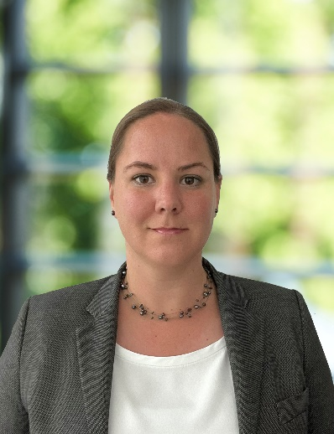
Name : Tamara Buijsse
Date of Birth : 25 August 1983
Nationality : Dutch
Country of Residence: Netherlands
Language(s) : Spoken - English, Dutch
Language(s) : Written – English, Dutch
Email: tamara@phae-maritime.com
Telephone: +31 6 4111 9445
Profession: General Counsel
Academic & Professional Qualification(s):
Postgraduate diploma in International Maritime law, WMU, 2022-2024
Post academic course on Transport law, Grotius, 2011
Master of Science in General Management, Nyenrode Business Universiteit, 2006-2008
Master in law, Maastricht University, 2001-2007
Professional Membership(s):
Singapore Chamber of Maritime Arbitration (Member)
Singapore Institute of Arbitrators (Fellow)
Institute of Chartered Shipbrokers (MICS)
Career & Professional Experience:
04.2026 – Current – General Counsel – BlueOOS
02.2022 – 03.2026 – General counsel – Lauritzen Bulkers
08.2020 – 01.2022 – Legal Counsel – Bunker Holding
08.2018 – 07.2020 – Contract Manager – ALE / Mammoet
11.2011 – 07.2018 – Claims Executive – Raets Marine / MS Amlin
12.2009 – 10.2011 – Lawyer – Dutch P&I Services
04.2008 – 11.2009 – Freight Forwarder – DHL Global Forwarding

Legal Knowledge relating to Shipping, Arbitration Practice and Procedure:
Dispute resolution, disputes arising out of (maritime) transport contracts subject to (international) arbitration, including (bareboat, time and voyage) charter parties and bills of lading, both on the claimants’ and the defendant’s side.
Having dealt with crane and heavy lift incidents, damage to quay and port structures, damage to vessels’ hull as well as pollution arising out of such incidents.
Having dealt with arbitration procedures in both common law and civil law jurisdictions.

TAMARA BUIJSSE
Listed Profession: inhouse counsel
- Write-up
Transport lawyer, specialized in chartering (bareboat, time charter, voyage charter) and ship operations, with a special interest in heavy lift operations
Experienced in international disputes relating to the day-to-day chartering and operations of vessels, and related contracts like (bareboat, time and voyage) charter parties and bills of lading.
Special interest in the on- and offshore heavy lift industry.

- Contact
Tel: +316 4111 9445
E-mail address: tamara@phae-maritime.com
Nationality: Netherlands
Country of Residence: Netherlands
Language(s): English, Dutch

- Main Practice Areas
Charter Parties (bareboat, time and voyage charter parties)
Bills of Lading
Heavy lift

