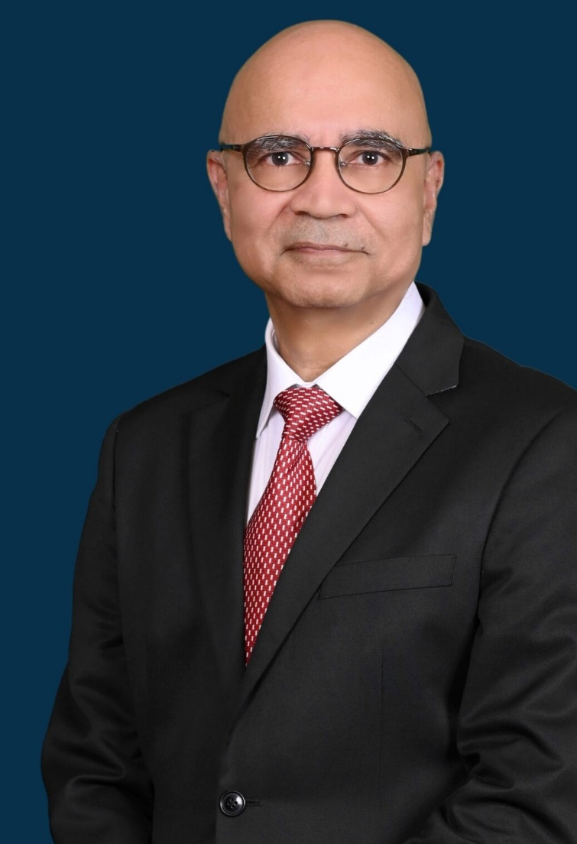

Prem Gurbani
28 Maxwell Road, Maxwell Chambers Suites,
#04-18A, Singapore 069120
Tel: (65) 6227 0218 Email: premgurbani@outlook.com

- Graduated from University of Singapore, Faculty of Law in 1977. Admitted to the Bar in January 1978. In practice for 49 years during which has had the opportunity to handle disputes of all manner including shareholders’ disputes, disputes relating to joint ventures, commodity contract disputes, international disputes relating to the sale of large-scale industrial machinery, infrastructure disputes, disputes involving company charges and mortgages, and shipping and maritime disputes.

- Founder and previously Senior Partner of Gurbani & Co. a commercial law practice in Singapore.

- Presently practicing as Arbitrator and Mediator in Maxwell Chambers Suites, Singapore.

- Consistently named as one of the leading practitioners in Singapore for Shipping/Maritime by Chambers, Who’s Who Legal (Shipping and Maritime) and other legal directories. Named by Chambers as Senior Statesman in Shipping Litigation, Singapore

- Previously (while still acting as Counsel) Senior Accredited Specialist in Shipping and Maritime Law appointed by the Singapore Academy of Law.

- Accredited Mediator, Singapore Mediation Centre.

- Accredited Mediator, Singapore International Mediation Centre.

Work History

Legal associate, Karthigesu & Arul, 1978 to 1980

Legal Associate and later non-equity partner, Netto, Low and Partners, 1980 to March 1982

Senior Partner, Prakash, Gurbani & Chong, 1982 to 1989

Senior Partner, Gurbani & Co, 1989 to 2012

Consultant, Gurbani & Co, 2012 to March 2019

Presently Director, PGurbani LLC

Areas in which presently engaged in arbitrations, mediations

- ICC, SIAC, LCIA, AIAC and other institutional arbitrations concerning disputes on joint ventures, shareholders’ disputes, commodity contract disputes, infrastructure disputes, disputes involving the sale and leasing of small aircraft, international disputes relating to the sale of large-scale industrial machinery, infrastructure disputes, and disputes involving company charges and mortgages.

- Ad hoc and institutional arbitrations involving litigious and non-litigious aspects of maritime law and international trade including ship sale and purchase, ship financing, marine insurance, collisions at sea and carriage of goods by sea.

- Commodity contract disputes in arbitrations held under the Rules of the LMAA (London Maritime Arbitrations Association), GAFTA (Grain and Feed Trade Association, London) FOSFA (Federation of Oils, Seeds and Fats Association Ltd, London), ICC (International Chamber of Commerce), PORAM (Palm Oil Refiners Association of Malaysia), Federation of Cocoa Commerce (FCC), SIAC (Singapore International Arbitration Centre) and the SCMA (Singapore Chamber of Maritime Arbitration).

- Mediation of contractual disputes.

Professional Appointments

- Formerly, Director, Singapore Chamber of Maritime Arbitration (“SCMA”)
- Formerly, Director, Singapore Maritime Foundation
- Accredited Arbitrator, Singapore International Arbitration Centre
- Accredited Arbitrator, Singapore Chamber of Maritime Arbitration
- Accredited Arbitrator, Singapore Institute of Arbitrators.
- Accredited Arbitrator, Japan Commercial Arbitration Association.
- Accredited Arbitrator, Badan Arbitrase Nasional Indonesia (BANI Arbitration Center)
- Member, Panel of Mediators, SCMA – Singapore International Mediation Centre.
- Member, Panel of Associate Mediators, Singapore Mediation Centre
- Member, Panel of Maritime Mediators, Singapore Mediation Centre
- Formerly Lecturer, Singapore Management University, teaching Law of International Trade
- Formerly Course Director, Singapore Institute of Arbitrators/ Singapore Chamber of Maritime Arbitration Maritime Arbitrators Accreditation Program.

Memberships of Professional Bodies

- Fellow of the Singapore Institute of Arbitrators
- Fellow of the Chartered Institute of Arbitrators, London
- Supporting Member, London Maritime Arbitrators Association
- Law Society of Singapore
- Singapore Academy of Law
- Maritime Law Association of Singapore

Selected speaking engagements.

Regular speaker at regional seminars and talks, a selection of which is: -

- Speaker, Global Maritime Arbitration Conference 2023 organized by the Centre for Arbitration and Research, Maharashtra National Law University, Mumbai, 16 December 2023

- Speaker, Maritime law & Business Conference 2023, organized by the International Malaysian Society of Maritime Law, Kuala Lumpur, 12 May 2023

- Speaker, SCMA, Singapore Academy of Law Mock Arbitration sponsored by the Baltic Exchange, Singapore, September 2019

- Singapore Academy of Law Course for Industry Practitioners 2019

- Speaker, Maritime Arbitration – Tips on Rules and Practices, Singapore Institute of Arbitrators, August 2019

- Speaker, International Seminar on Maritime Law and Arbitration organized by BANI and SCMA, Jakarta, April 2015

